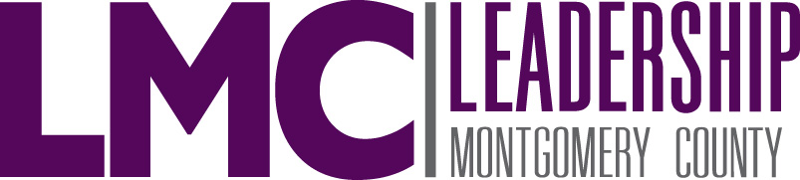

BOARD OF DIRECTORS

2022-2023

Amanda Trapp, Chairman of the Board, Class of 2007
Trapp Law Firm, PC

Brian Albert, Immediate Past Chairman of the Board, Class of 2016
The Strong Firm

Sarah Blakelock, Vice Chairman, Class of 2016
Conroe ISD

Directors Whose Terms Expire June 2023:

LaToya Collins, Class of 2016
Interfaith of The Woodlands
Eric Depoy, Class of 2016
The Depoy Realty Group

Laura Lea Palmer, Class of 2012
Conroe Economic Development Council

Danielle Scheiner, Class of 2006
Conroe Economic Development Council

Travis Smith, Class of 2018
JLL

Directors Whose Terms Expire June 2024:

Monica Bomkamp Enia, Class of 2014
Education for Tomorrow Alliance

Lupe Cuellar, Class of 2019
Exxon Mobil Corporation

Jennifer Hudson, Class of 2013
Starzyk & Associates

Randie Morton, Class of 2011
Better Bookkeepers

Todd Stephens, Class of 2019
The Woodlands Township

Directors Whose Terms Expire June 2025:

Karen Harwell, Treasurer, Class of 2015
Lone Star Family Health Center

Nicole Preston, Class of 2020
Community Impact Newspaper

Eric Rabel, Class of 2020
The Howard Hughes Corporation

Angela Storseth-Cooper, Secretary, Class of 2015
The US Oncology Network

Melissa Young, Class of 2009
Corporate Incentives

Directors Representing Chambers of Commerce:

Scott Harper, Class of 2006
Conroe/Lake Conroe Chamber of Commerce

JJ Hollie, Class of 2009
The Woodlands Area Chamber of Commerce

Executive Director
Sarah Rhea, Class of 2007

